1. COSINE SIGNAL

CODE:

clc;

t=0:0.1:pi;

y=cos(2\*pi\*t);

subplot(3,2,2);

plot(t,y);

ylabel('Voltage(Volts)->');

xlabel('(b)time(Sec)->');

title('COSINE SEQUENCE');

PLOT:

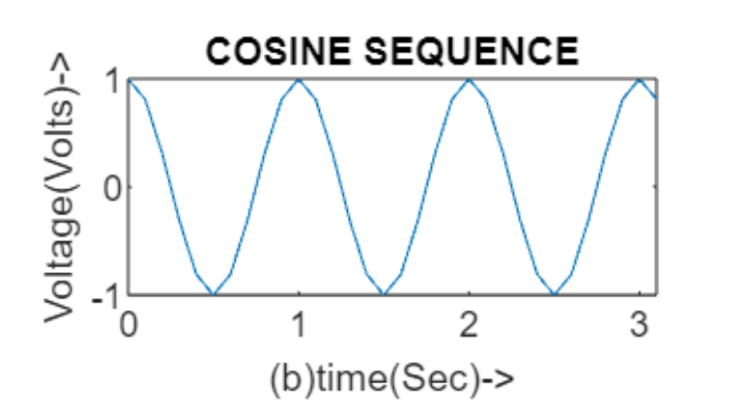

1. RAMP SEQUENCE

CODE:

clc;

n1=input('Enter the length of the ramp signal:');

t=0:n1;

subplot(3,2,3);

stem(t,t);

ylabel('Voltage(Volts)->');

xlabel('(c)N->');

title('RAMP SEQUENCE');

PLOT:

